**Ch’oe Sŭng-hŭi (**최승희; Japanese—Sai Shōki; **b. 24 November, 1911, Seoul, Republic of Korea; d. 8 August, 1969[?] [The exact year and location of death are unknown.])**

Known as the Dancing Princess of the Peninsula, based on the title of a Japanese-made film in which she appeared (*Hanto no Maihimei*), Ch’oe Sŭng-hŭi’s life and career spanned the volatile years of the Japanese occupation of Korea (1910-1945), two world wars, the Korean War, and the division of the Korean peninsula into the Republic of Korea (South Korea) and the Democratic People’s Republic of Korea (North Korea). Despite these complex circumstances, her favoured status with different governments at different times allowed her to travel in Asia, Europe, and North and Latin America, and provided extensive support for her dance activities during at least part of her time in North Korea. Her early training, together with opportunities to see contemporaneous developments in the performing arts during her travels, contributed to her evolving dance aesthetic, which, as it progressed, traversed stages exemplifying modernism’s diverse manifestations in the rejection and revision of tradition, attraction to images of an ‘other’, and embracing of experimentation. Ultimately, Ch’oe made important contributions to what constitutes distinctively Korean dance icons in the twenty-first century.

Training

Ch’oe’s interest in dance began in 1926 when her brother took her to see a performance by visiting Japanese modern dancer Ishii Baku (1886-1962). Mesmerized by what she saw, and despite personal and parental reservations that reflected the often negative status assigned to female dancers in Korea at the time, her brother encouraged her to pursue dance studies with Ishii. She followed him to Japan and studied with him over a period of eight years. Although her early training with Ishii included the Cecchetti style of ballet, Ch’oe focused largely on the modern dance her teacher had learned, which was influenced by the eurhythmics of Émile Jaques-Dalcroze and the German expressionist dance of Mary Wigman.

Ishii eventually became concerned with Ch’oe’s rejection of her Korean heritage and suggested that she return to the dances of her roots. After studying briefly with Han Sŏng-jun (1874-1941), a Korean dancer who happened to be in Tokyo and who was beginning to develop a new dance style strongly rooted in older Korean dances, she went back to Korea in the early 1930s to study these dances in the country of their origin.

During her training and artistic development it is also likely she saw a number of dance companies from other countries that performed in Asia, including Denishawn. And during a 1938-1940 tour of Europe and North and Latin America, she was exposed to a broad array of contemporary dance developments.

Major contributions to the Field and to Modernism

There are two discernable strands to Ch’oe’s early works: an Orientalist thread similar to the kinds of dances of companies such as Denishawn and individuals such as La Meri (Russell Meriwether Hughes—1898-1988), and an expressionist thread as represented by the dances of Mary Wigman (1886-1973). Among titles of some of the former are *Indian Dance*, *Love Song of India*, *Landscape of Egypt*, and one of her most popular and frequently-performed dances, *Bodhisattva*, which appears to have been inspired more by Buddhist figures of India than of Korea, and bears intriguing resemblances to United States dancer Ruth St. Denis’s *Kuan Yin*. Among the dances that parallel the expressionist aesthetic of Wigman are *Étude*, *Lyric Poem*, and *With No Path to Follow*. The last, as represented in photographs and verbal descriptions, included angular and tension-filled positions, a black costume revealing a bare midriff and bare arms, legs, and feet, emotion-filled facial expressions, and short, bobbed hair, all suggestive of some of the westernizing trends in dance and other areas of life in Japan and Korea at the time, including assertive feminist attitudes.

When Ishii urged Ch’oe to return to Korean dance, she began to abandon the outward manifestation of many of these early influences and seek a way to modernize the dances of her own heritage. However, the underlying philosophy of her earliest engagements with dance fostered a freedom of the body and a concern with individual expression that likely gave Ch’oe permission to develop artistically in the way she did and led to her changing embodiment of a Korean sense of modernity during the 1920s and 1930s.

Her artistic philosophy became anchored in a self-described concern with creating something that was distinctively Korean but that also reflected contemporary times—times that were strongly influenced by the modernity evolving in the western world. Thus, she turned to finding ways to adapt older Korean dances, or to create new ones that were in some way influenced by them, contributing to the evolution of iconic new Korean dances. Her *Monk’s Dance* was based on a Buddhist temple dance in which monks played a large drum; in *Fortune Teller’s Dance* she used implements and costuming suggestive of those used by shamans in ritual practices; and in *Drum Dance* she borrowed the large hour-glass drum used by men in performing traditions related to agricultural activities.

Legacy

Ch’oe’s reputation sometimes overshadows related contributions of such other Korean dancers as Han Sŏng-jun, Cho Taek-wŏn (1907-1976), Pae Ku-ja (1908-2003), Kim Ch’ŏn-hŭng (1909-2007), Han Yŏng-suk (1920-1989), Pae Ha-la (Halla Huhm; 1922-1994), Kim Paek-pong (1927- ), and Yi Mae-bang (1927- ). She was frequently placed her in the limelight by the political involvements of her socialist husband (An Mak [An Pil Sŭng], 1910-1955), who played a major role in her career and accompanied her on her tour abroad; the permission granted to her to perform in western countries during the politically heated times of the Japanese occupation; and the adoration given her by both some influential Korean and Japanese people based on her performing ability and her continually referenced beauty and representation of modern womanhood. As a ‘new woman’ (*shin yŏja*) sporting a bobbed haircut and western-style clothing, she acquired celebrity status, even appearing in advertisements for such things as stationery, make-up, and snacks. She was likely one of the first Korean dancers to perform in the West, and the dances for which she became most widely known were described by Koreans as new dance (*shin muyong*)—dances that departed from older practices of her own heritage, but that had a distinctively Korean stamp, and that clung to the modern dance genre’s philosophy of individuality and experimentation.

Throughout her career she embodied—and performed—the multi-faceted nature of what constituted the modernizing endeavor in dance in many places across the globe in the early to mid-twentieth century. Ultimately she developed what *she* considered a uniquely Korean version of that modernity. In the mid-1940s she, her husband, and children, fled to North Korea because of their political beliefs and purported pro-Japanese stance. She and her choreography became so highly favoured there that the government established a major training academy for her, and her subsequent impact contributed to the development of dramatic danced-stories (e.g., *Song of Liberation* and *Tale of Sado Fortress*) and mass performances that have since become the hallmark of North Korean dance. During travels to China she worked with Chinese Opera performer Mei Lan-fang, leading to cross-influences between both of these individuals and the art forms they practiced. Having once been written out of dance history in South Korea because of her assumed leftist political engagements, and eventually fallen out of governmental favour in North Korea, she has since been reinstated by the governments of both parts of the peninsula, where her influence on dances representing Korea continues to be seen.

**List of Selected Works**

(Dating Ch’oe’s choreographic works is problematic: She sometimes modified titles of her dances, as well as the choreography, and it is not always possible to determine if several dances with different titles were, in fact, essentially the same dance. Further, because she performed not only in Japan and Korea but in other countries as well, titles were translated and retranslated from one language to another and back again, with discrepancies sometimes occurring. Titles given below are intended to exemplify dances from the major periods described, some of which continue to be performed, in some variation, in the twenty-first century.)

Orientalist Works

*Bodhisattva*

*Indian Dance*

*Landscape of Egypt*

*Love Song of India*

Expressionist-style Dances

*Étude*

*Lyric Poem*

*Song of Grief*

*With No Path to Follow*

New Korean Dances

*Buddhist Temptress*

*Court Lady of Shiragi*

*Dream of Youth*

*Drum Dance*

*Ehea Noara*

*Fortune Teller’s Dance*

*Greatest General Under the Sun*

*Korean Vagabond*

*Melody of the Jade Flute*

*Monk’s Dance*

*Sword Dance*

*Three Traditional Rhythms*

*Young Korean Bridegroom*

North Korean Works

*Song of Liberation*

*Tale of Sado Fortress*

**References and Further Reading**

Ch’oe, Sŭng-hŭi (1936) *Watakushi no jijoden* [*My Autobiography*]. Tokyo: Nihon Shoso.

Chŏng, Pyŏng-ho (1995) *Ch’umch’unŭn Ch’oe Sŭng-hŭi—Segyerŭl hwiachabŭn Chosŏn yŏja* [*The Dancing Ch’oe Sŭng-hŭi—The Korean Woman Who Captivated the World*]. Seoul: The Deep-Rooted Tree Publishing House.

Park, Sang Mi (2006) “The Making of a Cultural Icon for the Japanese Empire: Choe Seung-hui’s U.S. Dance Tours and ‘New Asian Culture’ in the 1930s and 1940s,” *Positions* (14) 3: 597-632.

Van Zile, Judy (2001) *Perspectives on Korean Dance*. Connecticut: Wesleyan University Press.

----- (2011) “Blurring Tradition and Modernity: The Impact of Japanese Colonization and Ch’oe Sŭng-hŭi on Dance in South Korea Today,” in *Consuming Korean Tradition in Early and Late Modernity. Commodification, Tourism, and Performance*, Laurel Kendall (ed.). Honolulu: University of Hawai‘i Press, pp. 169-194.

**Paratextual Materials:**

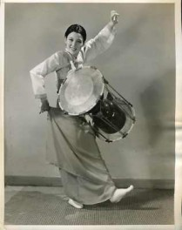

Ch’oe Sŭng-hŭi in *Drum Dance*

http://entertainment-memorabilia.bidstart.com/Sai-Shoki-Korean-Dancer-8x10-Photo-B9184-/20584772/a.html

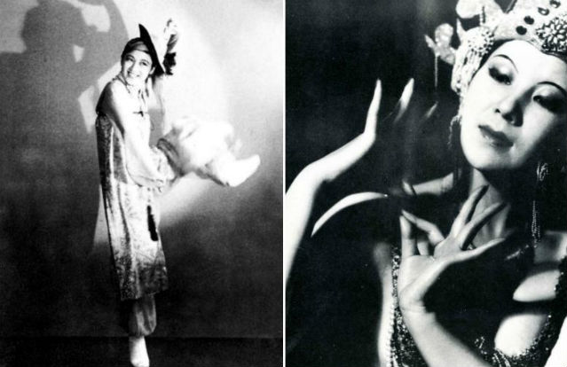

Ch’oe Sŭng-hŭi in *Hallyangmu* (Dance of Man of Leisure)

http://www.hancinema.net/original-hallyu-star-choi-seung-hee-reborn-37956.html

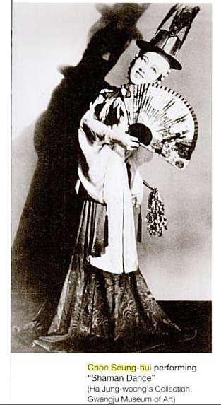

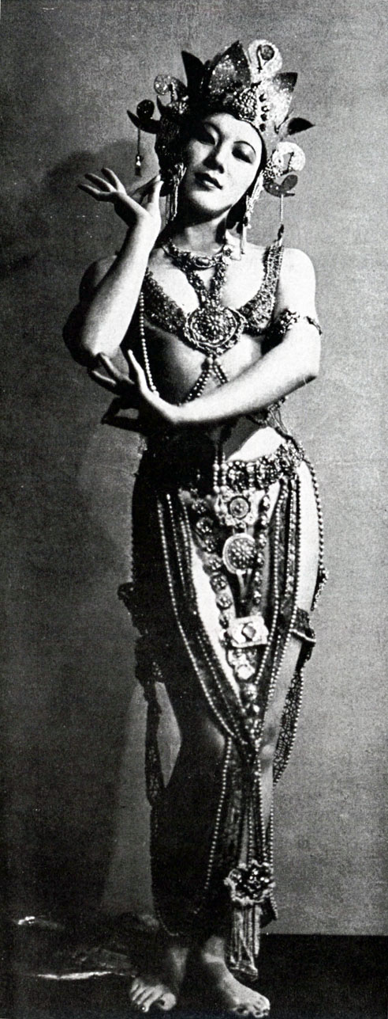 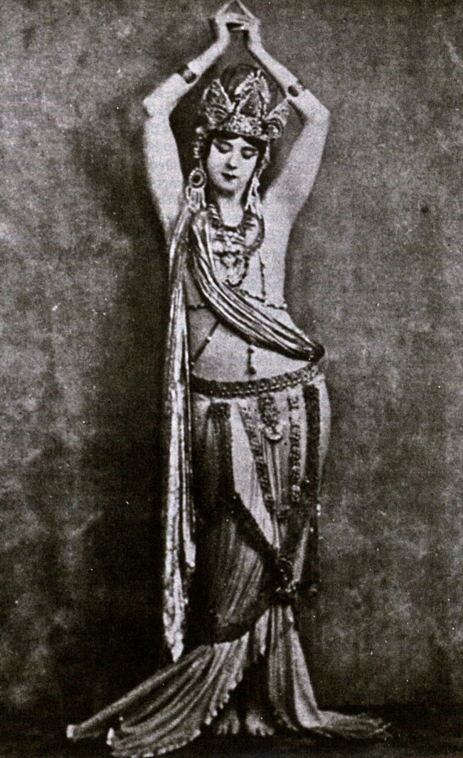

Ch’oe Sŭng-hŭi performing *Bodhisattva* (on the left) and Ruth St. Denis performing *Kuan* *Yin* (on the right) (Left image: Soichi Sunami [Dance Collection, New York Public Library]; Right image: Jane Sherman Collection)

Image on the left should be attributed as I’ve indicated. Permission to use should be obtained from: Reiko Kopelson (the photographer’s daughter), **kopelson@pipeline.com**

Image on the right should be attributed as indicated. Jane Sherman is now deceased. Dance Collection of NY Public Library has been unable to find any “estate holders” from whom permission can be obtained. I obtained the image, and permission to use it, from Jane Sherman while she was still alive. At that time, I requested permission to use it in my book, *Perspectives on Korean Dance*. Based on our correspondence and her generosity in sending me an original, I have assumed it is OK to use in additional educational contexts.

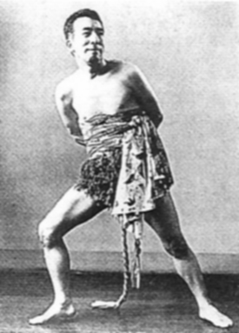

Japanese dancer Ishii Baku, Ch’oe Sŭng-hŭi’s primary teacher

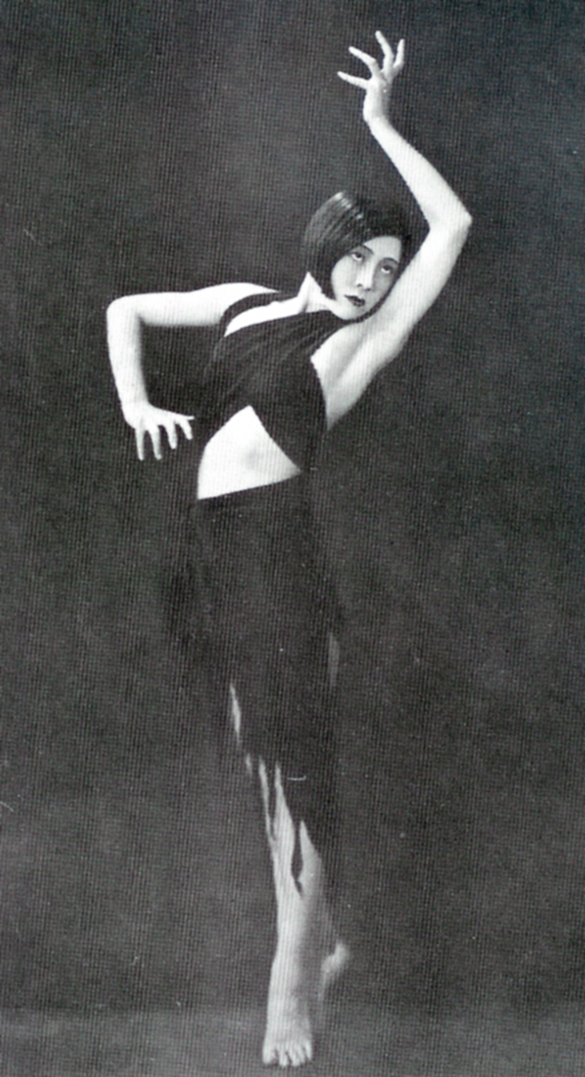

Ch’oe Sŭng-hŭi in *With No Path to Follow*

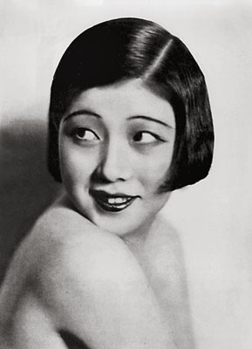

Ch’oe Sŭng-hŭi

http://gwangjublog.com/seung-hee-choi-a-garden-in-italy-1936/

(source: noonbit.co.kr)

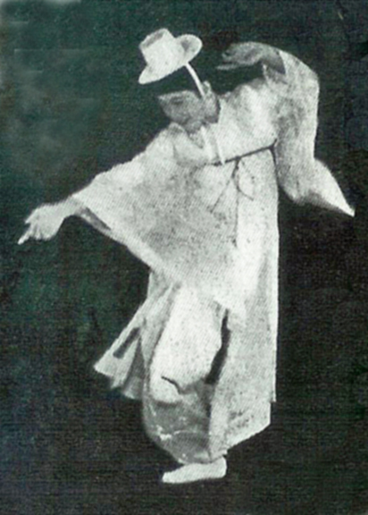

Ch’oe Sŭng-hŭi in *Ehea Noara*

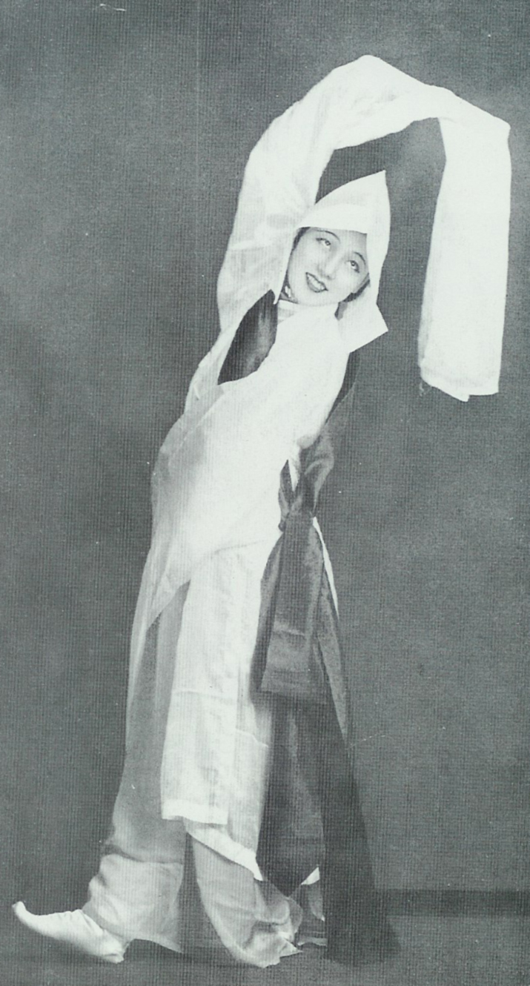

Ch’oe Sŭng-hŭi in *Monk’s Dance*

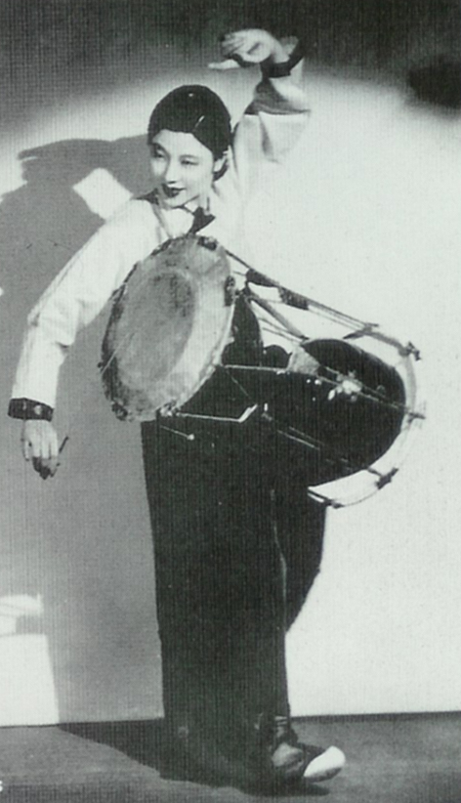

Ch’oe Sŭng-hŭi in *Drum Dance*

Films

*Choi Seunghee. The Korean Dancer*. Kultur Video. 2001

(Includes brief excerpts of some of the only footage of Ch’oe performing her new Korean dances, as well as some of her dances in North Korea. Not all solo dancers are Ch’oe.)

Judy Van Zile